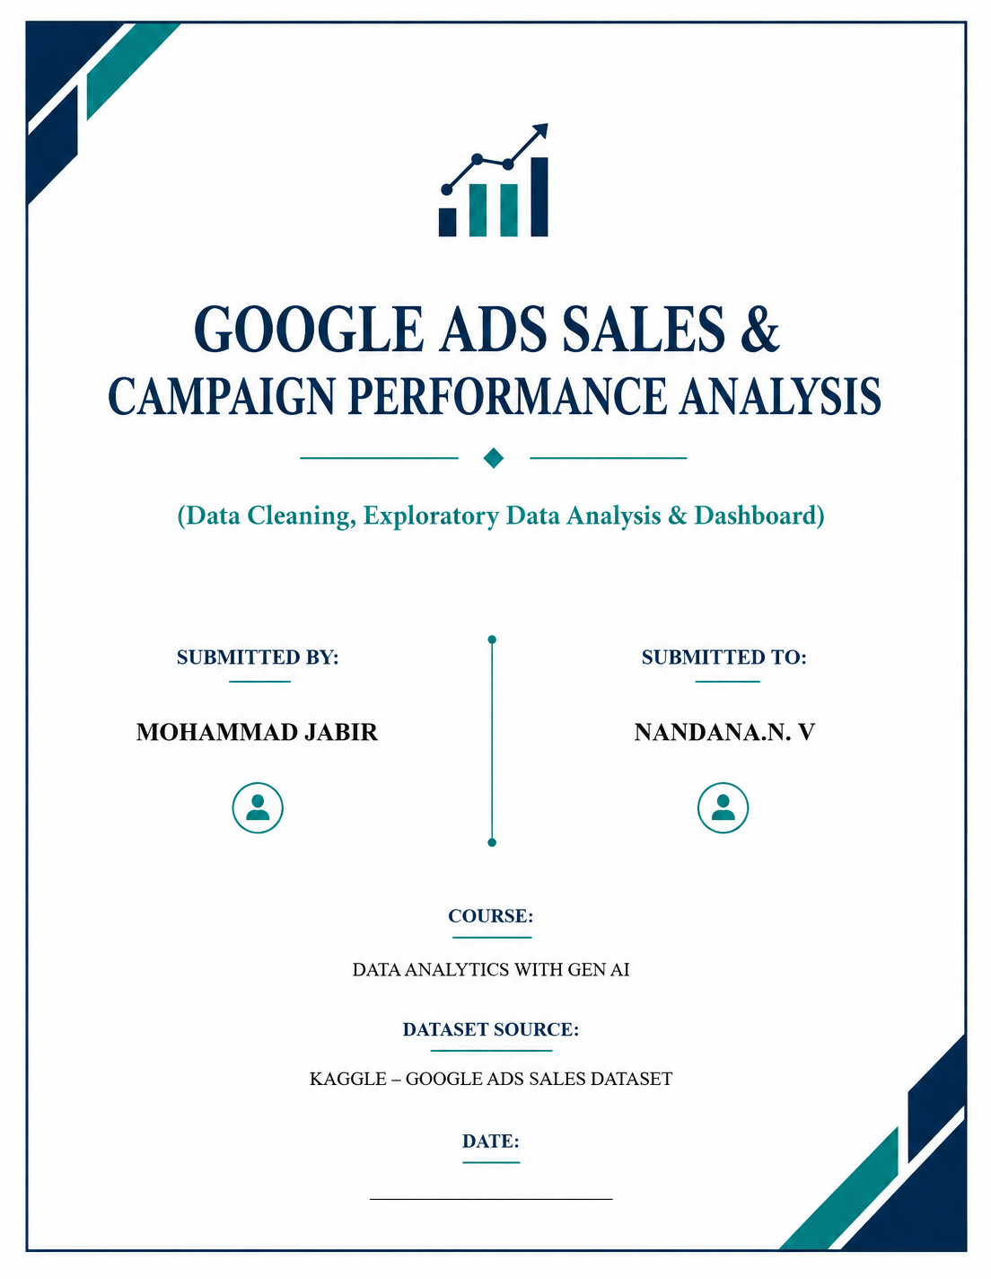
04 - 09 - 2026
Date of Submission:

CONTENTS

SL.NO | TITLE | PAGE.NO
1 | INTRODUCTION | 3
2 | DATASET DESCRIPTION | 4
3 | DATA CLEANING & PREPROCESSING | 6
4 | DATA ANALYSIS & EXPLORATION | 11
4.1 | Business Questions | 11
4.2 | Key Performance Indicators (KPIs) | 11
4.3 | KPI Calculation and Results | 12
4.4 | Pivot Table & Charts | 12
4.5 | Slicer | 23
4.6 | Dashboard | 23
5 | CONCLUSION | 25

1. INTRODUCTION
1.1 Project Overview
Digital advertising is an important part of modern business. Google Ads allows businesses to promote their products and services through online advertisements. These advertisements generate data such as impressions, clicks, leads, conversions, advertising cost, and sales.
This project focuses on analyzing Google Ads campaign data to understand campaign performance and identify useful business insights. The project includes data cleaning, exploratory data analysis, visualization, and dashboard creation using the available advertising data.
1.2 Problem Statement
Raw advertising data may contain missing values, duplicate records, inconsistent text, different date formats, and formatting issues. These problems can affect the accuracy of analysis and business decisions.
The purpose of this project is to clean and analyze the Google Ads dataset and use the cleaned data to evaluate campaign performance based on clicks, impressions, leads, conversions, cost, and sales.
1.3 Objectives
The main objectives of this project are:
- To understand the Google Ads dataset and its structure.
- To identify data-quality problems in the raw dataset.
- To clean and preprocess the data.
- To analyze advertising campaign performance.
- To study clicks, impressions, leads, conversions, cost, and sales.
- To create meaningful visualizations using the analyzed data.
- To develop an interactive dashboard.
- To identify useful insights that can support better advertising decisions.
2. DATASET DESCRIPTION
2.1 Dataset Source
The dataset used for this project is the Google Ads Sales Dataset, obtained from Kaggle. The dataset contains advertising campaign information that can be used to analyze the performance of online advertisements.
The dataset includes information related to impressions, clicks, cost, leads, conversions, sales amount, campaign dates, locations, devices, and keywords.

2.2 Dataset Overview
The raw dataset contains 2,600 records and 13 columns.
Each record represents an advertisement/campaign data entry. The dataset provides information that can be used to evaluate the performance of Google Ads campaigns and understand the relationship between advertising activity, conversions, and sales.

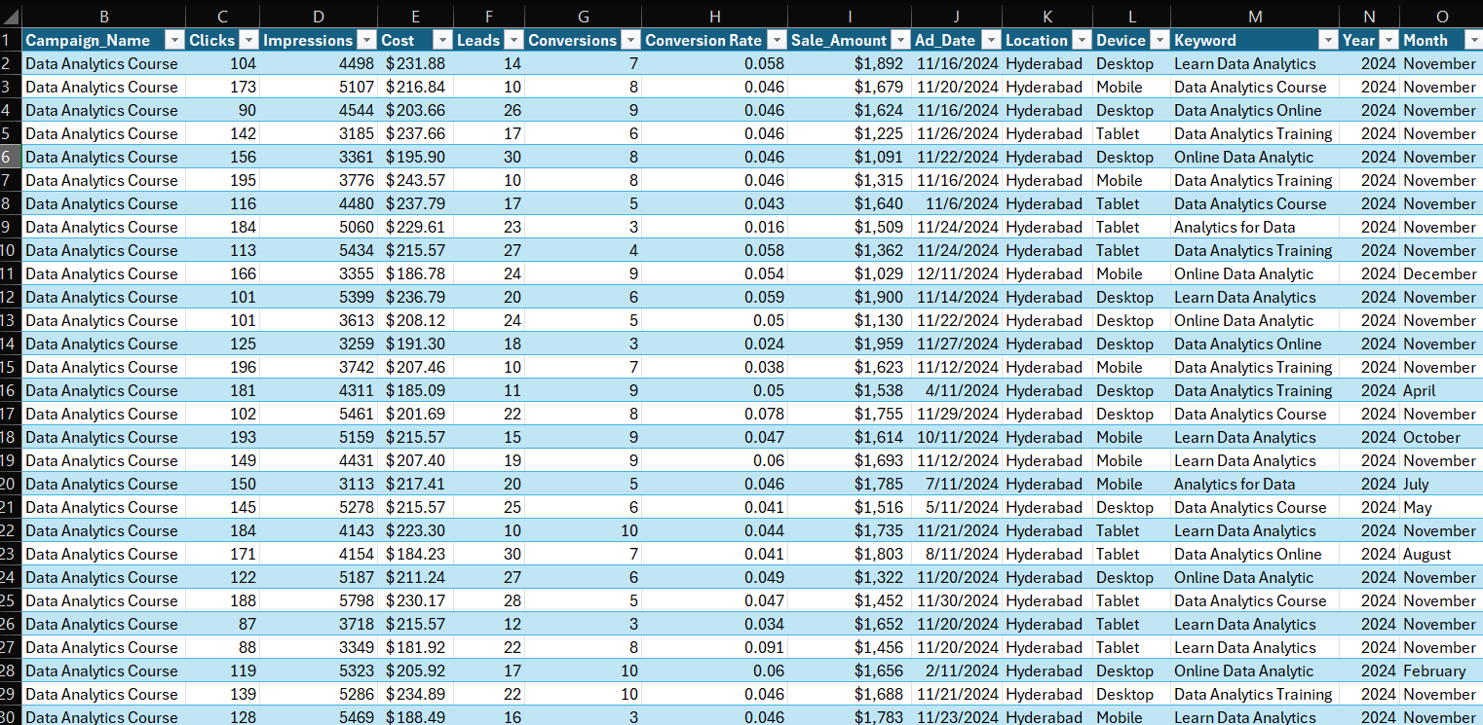

Dataset Summary

Item | Details
Dataset Name | Google Ads Sales Dataset
Source | Kaggle
Number of Records | 2,600
Number of Column | 13
Data Type | Advertising / Marketing Data
Main Focus | Google Ads Campaign Performance
Analysis Tool | Microsoft Excel

2.3 Column Description

Column | Description | Data Type
Ad_ID | Unique identification number for an advertisement | Text
Campaign_Name | Name of the advertising campaign | Text
Clicks | Number of clicks received by the advertisement | Numeric
Impressions | Number of times the advertisement was displayed | Numeric
Cost | Amount spent on the advertisement | Currency
Leads | Number of leads generated | Numeric
Conversions | Number of successful conversions | Numeric
Conversion Rate | Rate at which clicks or leads result in conversions | Percentage
Sale_Amount | Sales amount generated from the advertisement | Currency
Ad_Date | Date associated with the advertisement
  Date
Location | Location associated with the advertisement
  Text
Device | Device used for the advertisement interaction | Text
Keyword | Keyword associated with the advertisement | Text

2.4 Initial Data Quality Findings
During the initial inspection of the raw dataset, several data-quality issues were identified. These include:
- Missing values in several columns.
- Inconsistent campaign names.
- Inconsistent capitalization in location and device values.
- Different date formats.
- Currency symbols in numerical fields such as Cost and Sale_Amount.
- Missing values in Conversion Rate.
These issues need to be addressed before performing further analysis.

3. DATA CLEANING & PREPROCESSING
3.1 Adjusting Column Width and Row Height
The column widths and row heights were adjusted to improve the readability and visibility of the dataset.
- AutoFit Column Width → Alt + H + O + I
- AutoFit Row Height → Alt + H + O + A

3.2 Converting the Dataset into an Excel Table
The dataset was converted into an Excel Table to make the data easier to manage, filter, sort, and access by individual columns. The table structure also provides a convenient foundation for further data cleaning and analysis.

  - Removing Duplicates
The dataset was checked for duplicate records using the Ad_ID field, which uniquely identifies each advertisement. No duplicate Ad_IDs were found in the dataset. Therefore, no records were removed during this step.

  - Find and Replace
The Find and Replace feature was used to identify and correct inconsistent campaign names. Several variations of the same campaign name were found in the raw dataset. These variations were standardized to Data Analytics Course to maintain consistency and improve the accuracy of further analysis.

Original Value | Standardized Value | Records
DataAnalyticCourse | Data Analytics Course | 637
Data Analytics Corse | Data Analytics Course | 647
Data Anlytics Corse | Data Analytics Course | 636
Data Analytcis Course | Data Analytics Course | 680

The Location column also contained inconsistent spellings of Hyderabad. The values hyderabad, Hyderbad, and hydrebad were identified and standardized to Hyderabad using the Find and Replace feature. This improved consistency in the Location column and will help produce accurate location-based analysis and visualizations.

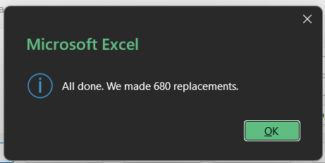
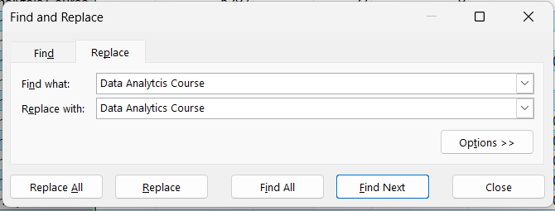
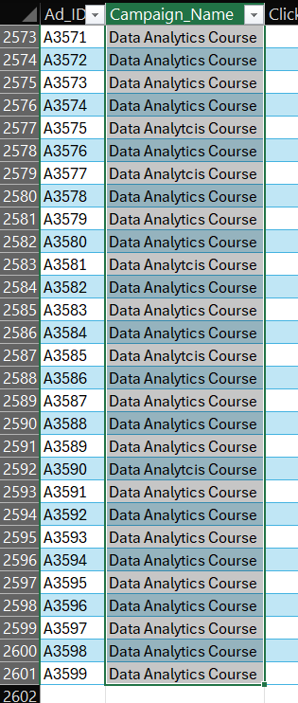

  - Standardizing Device Values Using PROPER()
The Device column contained inconsistent capitalization, such as desktop, Desktop, mobile, Mobile, tablet, and TABLET. Since these values represent the same device categories, the PROPER() function was used to standardize their capitalization. The cleaned values were standardized as Desktop, Mobile, and Tablet.

  - Cleaning and Standardizing Keyword Values
The Keyword column was examined for spelling and capitalization inconsistencies. Two spelling errors, anaytics and analitics, were corrected to analytics using Find and Replace. The PROPER() function was then used to standardize capitalization across the Keyword column. The cleaned keyword values were reviewed to ensure that the original meaning of the keywords was preserved.

  - Handling Missing Values
— Clicks
The Clicks column contained missing values. The missing values were replaced with the mean value of 139. The mean was selected because it provides a representative average of the number of clicks received by the advertisements.

– Impressions
The Impressions column contained 54 missing values. The missing values were replaced with the median value of 4,518. The median was selected because Impressions is a numerical count and the median is less affected by unusually high or low values, making it a suitable measure for representing a typical observation.

– Cost
The Cost column contained missing values. The missing values were replaced with the median value of $215.57. The median was selected because it provides a representative value for the typical advertising cost and is less affected by potential extreme values.

– Leads
The Leads column contained 48 missing values. The missing values were replaced with the median value of 20. The median was selected because it represents the typical number of leads and is less affected by unusually high or low values.

– Conversions
The Conversions column contained 74 missing values. The missing values were replaced with the median value of 7. The median was selected because it represents a typical number of conversions and is less affected by unusually high or low values.

– Conversion Rate
The Conversion Rate column contained missing values. The missing values were replaced with the median value of 0.046. The median was selected because it represents the typical conversion rate and is less affected by unusually high or low values.

– Sale Amount
The Sale_Amount column contained missing values. The missing values were replaced with the median value of $1,505. The median was selected because it provides a representative value for typical sales and is less affected by unusually high or low sale amounts.

3.8 Date Standardization and Date Extraction
The Ad_Date column contained dates in different formats, and some date values were stored as text. The text-formatted dates were converted into proper date values using the Text to Columns feature.

The original Ad_Date column was retained to preserve the actual date information. Additional Month and Year columns were created to support time-based analysis and visualization.
- Month: Extracted using =TEXT([@Ad_Date],"mmmm")
- Year: Extracted using =YEAR([@Ad_Date])

This structure makes it easier to analyze advertising performance by month and year using PivotTables and charts.

3.9 Final Data Quality Verification
The cleaned dataset was reviewed to ensure that duplicate records, inconsistent text values, missing values, and date-format issues were properly addressed. The data was checked for consistency and accuracy before proceeding to the analysis stage.

4. DATA ANALYSIS & EXPLORATION
4.1 Business Questions
- What is the overall advertising performance?
- How much was spent on advertising, and how much sales revenue was generated?
- Which campaign performed best?
- Which keyword generated the most conversions?
- Which device performed best?
- How does advertising performance vary by location?
- How does advertising performance change by month?
- Which campaigns have the highest conversion rate?
- Which campaigns generate the best return on investment (ROI)?
- What factors are associated with better sales and conversions?

4.2 Key Performance Indicators (KPIs)

KPI | Description
Total Clicks | Total number of clicks received by the advertisements.
Total Impressions | Total number of times the advertisements were displayed.
Total Cost | Total amount spent on advertising.
Total Leads | Total number of leads generated by the advertisements.
Total Conversions | Total number of successful conversions generated by the advertisements.
Total Sale Amount | Total sales revenue generated by the advertisements.
CTR (Click-Through Rate) | Percentage of impressions that resulted in clicks.
Conversion Rate | Percentage of clicks that resulted in conversions.

4.3 KPI Calculation and Results

KPI | Formula | Result
Total Clicks | Sum of Clicks | 361,293
Total Impressions | Sum of Impressions | 11,760,245
Total Cost | Sum of Cost | $559,282.10
Total Leads | Sum of Leads | 52,010
Total Conversions | Sum of Conversions | 16,985
Total Sales | Sum of Sale Amount | $3,897,368
CTR | Clicks ÷ Impressions × 100 | 3.07%
CPC | Cost ÷ Clicks | $1.55
CPL | Cost ÷ Leads | $10.75
Conversion Rate | Conversions ÷ Clicks × 100 | 4.70%
CPA | Cost ÷ Conversions | $32.93
ROAS | Sales ÷ Cost | 6.97x
ROI | (Sales − Cost) ÷ Cost × 100 | 597%

4.4 PIVOT TABLE AND CHARTS - Analysis
1. Which keyword generated the highest sales?

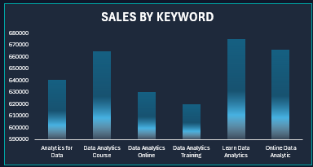

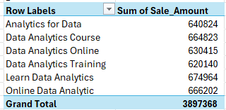

Interpretation
This chart compares the total sales generated by different keywords. Learn Data Analytics generated the highest sales at $674,964, followed by Online Data Analytic at $666,202 and Data Analytics Course at $664,823. Data Analytics Training generated the lowest sales at $620,140. Overall, sales performance is relatively close across all keywords, with Learn Data Analytics performing the best.

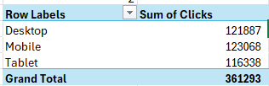
2. Which device received the highest number of clicks?

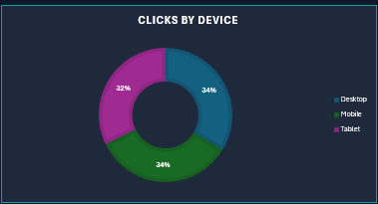

Interpretation
This chart compares the total number of clicks received from different devices. Mobile generated the highest number of clicks with 123,068, followed closely by Desktop with 121,887 clicks. Tablet received the lowest number of clicks with 116,338. The distribution is relatively balanced across all three devices, with mobile accounting for approximately 34% of total clicks.

3. Which keyword generated the highest number of conversions?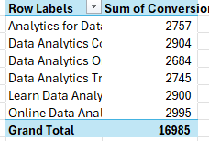
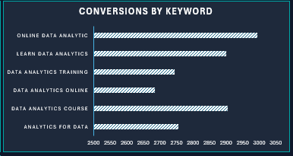

Interpretation
This chart compares the total number of conversions generated by different keywords. Online Data Analytic generated the highest number of conversions with 2,995, followed by Data Analytics Course with 2,904 and Learn Data Analytics with 2,900. Data Analytics Online generated the lowest number of conversions with 2,684. Overall, Online Data Analytic generated the highest number of conversions among the keywords analyzed.

4. Which device generated the highest sales?
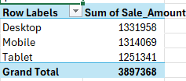

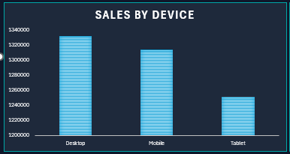
Interpretation
This chart compares the total sales generated from different devices. Desktop generated the highest sales with $1,331,958, followed by Mobile with $1,314,069. Tablet generated the lowest sales with $1,251,341. Overall, desktop and mobile contributed similar sales, while tablet recorded comparatively lower sales.

5. How do monthly sales vary throughout the year?
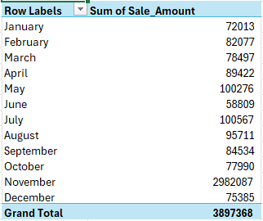

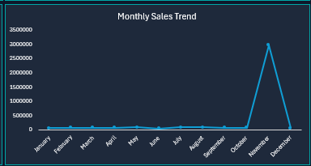

Interpretation
This chart shows the monthly sales trend throughout the year. Sales remained relatively consistent from January to October, with monthly sales generally ranging between approximately $58,809 and $100,567. However, November recorded an exceptional spike in sales of $2,982,087, which was substantially higher than all other months. Sales then decreased sharply to $75,385 in December. The unusually high November sales had a major impact on the overall annual sales performance and should be investigated further to identify the factors responsible for this increase.

6. How do monthly conversions vary throughout the year?
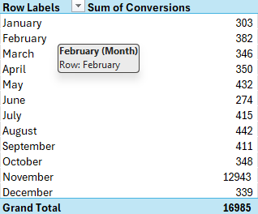

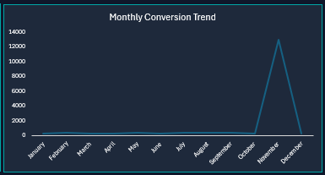
Interpretation
This chart shows the monthly conversion trend throughout the year. Conversions remained relatively consistent from January to October, ranging between 274 and 442 conversions. However, November recorded an exceptional spike with 12,943 conversions, which was substantially higher than all other months. Conversions then decreased sharply to 339 in December. The unusually high number of conversions in November had a major impact on the overall annual conversion performance and should be investigated further to identify the factors responsible for this increase.

7. How do monthly leads vary throughout the year?
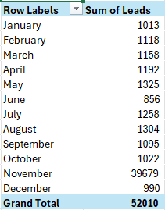

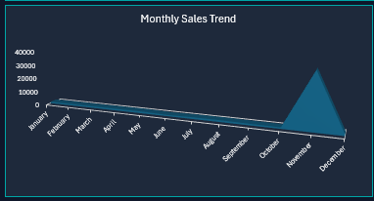

Interpretation
This chart shows the monthly trend in leads throughout the year. Lead generation remained relatively consistent from January to October, with monthly leads generally ranging between 856 and 1,325. However, November recorded an exceptional spike of 39,679 leads, which was substantially higher than all other months. Leads then decreased sharply to 990 in December. The unusually high number of leads in November had a major impact on the overall annual lead performance and should be investigated further to identify the factors responsible for this increase.

8. Which keyword achieved the highest CTR?
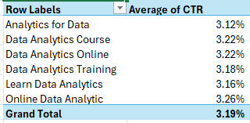

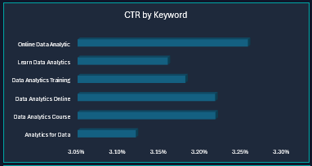

Interpretation
This chart compares the average click-through rate (CTR) across different keywords. Online Data Analytic achieved the highest CTR at 3.26%, followed by Data Analytics Course and Data Analytics Online, both at 3.22%. Analytics for Data recorded the lowest CTR at 3.12%. Although the differences are relatively small, Online Data Analytic performed best in attracting clicks relative to its impressions.

9. Which device achieved the highest conversion rate?
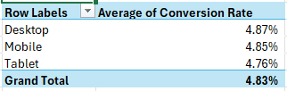

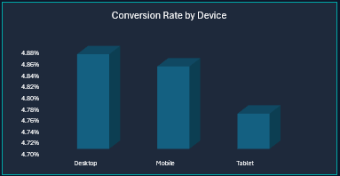

Interpretation
This chart compares the average conversion rate across different devices. Desktop achieved the highest conversion rate at 4.87%, followed closely by Mobile at 4.85%. Tablet recorded the lowest conversion rate at 4.76%. The conversion rates across all three devices are relatively similar, indicating consistent conversion performance across devices.

10. Which device generated the highest number of conversions?
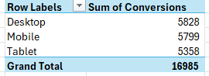

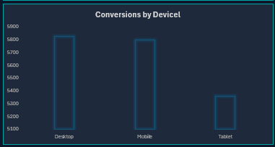

Interpretation
This chart compares the total number of conversions generated across different devices. Desktop generated the highest number of conversions with 5,687, followed by Tablet with 5,653 and Mobile with 5,645. The conversion counts are very close across all three devices, indicating that conversions were distributed relatively evenly among the devices.

4.5 Slicer
Slicers were added to the dashboard to provide an interactive way to filter and analyze the Google Ads data. The dashboard contains two slicers: Device and Keyword.
The Device slicer allows users to filter the dashboard based on Desktop, Mobile, or Tablet performance. The Keyword slicer allows users to analyze the performance of individual advertising keywords.
When a slicer option is selected, the connected PivotTables and charts automatically update to display the corresponding filtered results. This makes it easier to compare campaign performance and identify specific trends and insights without manually filtering the dataset.
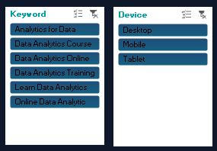

4.6 Dashboard
The Google Ads Sales & Campaign Performance Dashboard was created to provide a clear and interactive overview of advertising performance. It brings together key performance indicators, PivotCharts, and interactive slicers in a single view.
The dashboard contains eight KPI cards displaying Total Cost, Total Sale Amount, Total Clicks, Total Leads, Total Conversions, Conversion Rate, ROAS, and ROI. It also includes ten visualizations covering keyword, device, and monthly performance.
Two interactive slicers, Device and Keyword, allow users to filter the dashboard and analyze specific segments of the advertising data. The dashboard provides a consolidated view of campaign performance and helps identify important trends, high-performing areas, and opportunities for improvement.
A Business Recommendations section was also included to summarize key actions based on the analysis, particularly the unusual increase in sales, leads, and conversions observed in November.
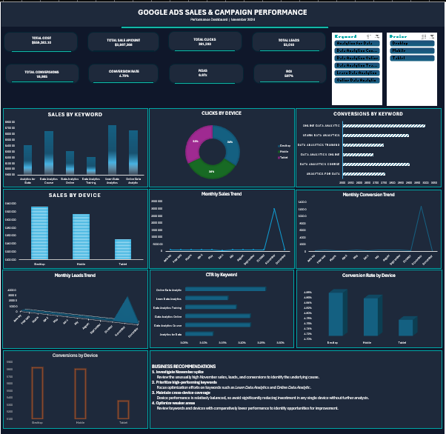

5. CONCLUSION
The Google Ads Sales & Campaign Performance Analysis project provided a comprehensive analysis of advertising performance using Excel. The dataset was cleaned and prepared by handling missing values, removing duplicates, standardizing text and date formats, and creating additional calculated fields such as Month, Year, and CTR.
PivotTables and PivotCharts were used to analyze sales, clicks, leads, conversions, CTR, conversion rate, device performance, keyword performance, and monthly trends. The analysis showed that overall campaign performance was strong, with a 4.70% conversion rate, 6.97× ROAS, and 597% ROI.
The analysis also identified an unusual spike in November, when sales, leads, and conversions increased significantly compared with other months. This finding highlights the importance of investigating unusual patterns before making business decisions.
An interactive dashboard with 8 KPIs, 10 visualizations, 2 slicers, and business recommendations was developed to present the findings in a clear and user-friendly format.
Overall, this project strengthened practical skills in data cleaning, Excel functions, PivotTables, data visualization, dashboard development, KPI analysis, and business insight generation. It demonstrates how raw advertising data can be transformed into meaningful insights that support data-driven business decisions.

